[16pt] Title: Subtitle

[12pt] First Author Name (e.g., SUZUKI, Kaoru)* and Second Author Name (e.g., SMITH, Kerry)**

[10pt] *First Author University
email@address
**Second Author University
email@address

Abstract
Write a brief (max 200 word) synopsis of your paper in order to provide a quick outline of your presentation, giving the reader an overview of the research.

Keywords: no, more, than, five, words

1. Introduction
The following are the guidelines for preparing your paper for the JAAL in JACET 2023 Proceedings. The paper must be sent in the form of a Microsoft Word (2003 or later) and a PDF on the JAAL in JACET 2023 website. The deadline is Friday, January 5, 2024 (11:59 PM Japan Standard Time). Whatever the reason, we will not be able to accept your paper after this time. The proceedings will be provided on the website.

2. How to Format the Page
Manuscripts should be written using this template, carefully following the guidelines provided by the Editorial Board.

2.1 Formats
In formatting your A4-size paper, set top and bottom margins to 30mm, left and right margins to 15mm, and left- and right-justify your columns. Do not put page numbers in your paper. The manuscript (except for the title, author name(s), abstract and keywords) needs to be written in a two-column format.

2.2 Fonts
Follow the font sizes specified in Table 1. Use Times New Roman.

[9pt] Table 1
Fonts for Papers
Font Size | Style | Text
16pt | bold | paper title (max 3 lines) centered
12pt |  | authors’ names (FAMYLY NAME, Given Name)
10pt | italics | authors’ affiliations, email addresses
10pt | bold | section titles
10pt |  | abstract, main text, subheadings
9pt | italics | table titles, figure titles
9pt |  | tables, figures, notes, acknowledgements, references, appendices
Note. Any notes can be added here.

3. Tables and Figures
Avoid placing tables and figures before their first mention in the text.

[9pt] Figure 1
Sample Figure
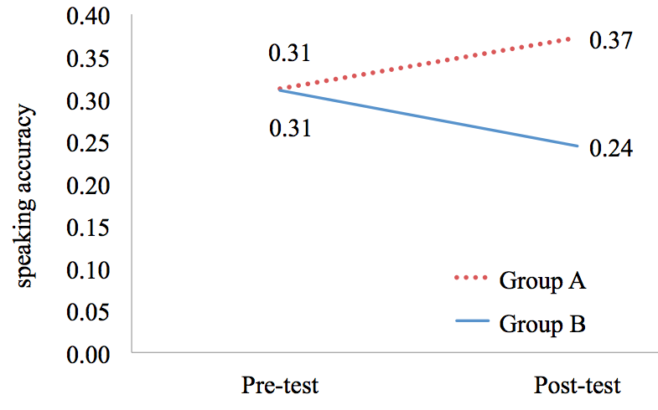
Note. Any notes can be added here.

4. Contact
If you have a question, read this document and the guidelines carefully first. If you cannot find the answer, e-mail us at jaalproceedings@gmail.com. Because it takes some time to reply, questions will be accepted only until December 31, 2023. Beyond this time, no further questions will be accepted.

[9pt] Notes
¹ Notes may be added here if necessary.
² . . .

Acknowledgements
Add an acknowledgements section if necessary.

References
List all the quoted studies in alphabetical order. The following reference examples are based on the Publication Manual of the American Psychological Association, 7th edition. Refer to the Publication Manual if you cannot find what you want to see below. [Please do not actually categorize references as in the following examples such as (Authored book) or (Edited book), but list all the references in alphabetical order.]

(Authored book)
American Psychological Association. (2019). Publication manual of the American Psychological Association (7th ed.). American Psychological Association.
Huston, A. C., Wartella, E., Donnerstein, E., Scantlin, R., & Kotler, J. (1998). Measuring the effects of sexual content in the media: A report to the Kaiser Family Foundation. The Kaiser Family Foundation.
Karmiloff-Smith, A. (1992). Beyond modularity: A developmental perspective on cognitive science. MIT Press.

(Edited book)
Duck, S. (Ed.). (1988). Handbook of personal relationships: Theory, research, and interventions. Wiley.

(Journal article)
Benson, P. (2006). Autonomy in language teaching and learning. Language Teaching, 40(1), 20–40. https://doi.org/10.1017/S0261444806003958
Galloway, N., & Rose, H. (in press). English medium instruction and the English language practitioner. ELT Journal. Advance online publication. https://doi.org/10.1093/elt/ccaa063

(Chapter in an edited book)
Berndt, T. J., & Savin-Williams, R. C. (1993). Peer relations and friendships. In P. H. Tolan, & B. J. Kohler (Eds.), Handbook of clinical research and practice with adolescents (pp. 203–219). Wiley.
Reis, H. T., & Shaver, P. (1988). Intimacy as an interpersonal process. In S. Duck (Ed.), Handbook of personal relationships: Theory, research, and interventions (pp. 367–389). Wiley.

(Works in another language)
Uzawa, H. (1998). Nihon no kyoiku wo kangaeru [Thinking about Japanese education]. Iwanami Shoten.

Appendix A: The Title of Appendix A
Add an appendix [appendices] section if necessary.

Appendix B: The Title of Appendix B

