[16pt] The Title Should Be 16-point, Boldface, Centered: Please Follow the Capitalization Rules of APA 7th Edition (Section 6.17)

[12pt] First Author Name* and Second Author Name**

[10pt] *First Author’s Affiliation
email@address
**Second Author’s Affiliation
email@address

Abstract
Write a brief (max 300 word) synopsis of your paper in order to provide a quick outline of your presentation, giving the reader an overview of the research.

Keywords: no, more, than, five, words

- Introduction
The following are the guidelines for preparing your paper for The JACET International Convention Proceedings (hereafter, the Proceedings). The paper must be sent in the form of PDF. As a general rule, the Editorial Board of the Proceedings will not change the submitted manuscripts. The deadline is Monday, June 14, 2021 (11:59 PM Japan Standard Time). Whatever the reason, we will not be able to accept your paper after this time.

- How to Format the Page
The Proceedings is the collection of manuscripts about oral presentations which are going to be given at the JACET 60th Commemorative International Convention (Online, 2021). The manuscripts are not going to be peer-reviewed.

  - Formats
In formatting your A4-size paper, set all margins to 15 mm, and left- and right-justify your columns. Do not put page numbers in your paper. The manuscript (except for the title, author name(s), abstract, and keywords) needs to be written in a two-column format.

  - Fonts
Follow the font sizes specified in Table 1. Use Times New Roman.

[9pt] Table 1
Fonts for Papers
Font  Size | Style | Text
16pt | bold | paper title (max 3 lines) centered
12pt |  | authors’ names
10pt | italics | authors’ affiliations, email addresses
10pt | bold | section titles
10pt |  | abstract, main text, subheadings
9pt | italics | table titles, figure titles
9pt |  | tables, figures, notes, acknowledgements, references, appendices
Note. Any notes can be added here.

- Tables and Figures
Avoid placing tables and figures before their first mention in the text.

[9pt] Figure 1
Sample Figure
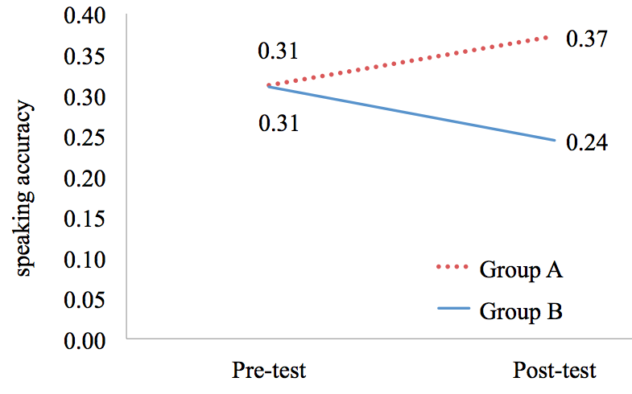
Note. Any notes can be added here.

- Contact
If you have a question, read this document carefully first. You may find its answer. If you cannot find the answer here, e-mail us at jacet60thproceedings@jacet.org. It may take some time to reply.

[9pt] Notes
¹ Notes may be added here if necessary.
² . . .

Acknowledgements
Add an acknowledgements section if necessary.

References
[List all the quoted studies in alphabetical order. The following reference examples are based on the APA 7th edition. Refer to this book if you cannot find what you want to see below. Please note that there is no need to categorize references as in the following examples.]

(Authored book)
American Psychological Association. (2019). Publication manual of the American Psychological Association (7th ed.). American Psychological Association.
Huston, A. C., Wartella, E., Donnerstein, E., Scantlin, R., & Kotler, J. (1998). Measuring the effects of sexual content in the media: A report to the Kaiser Family Foundation. The Kaiser Family Foundation.
Karmiloff-Smith, A. (1992). Beyond modularity: A developmental perspective on cognitive science. MIT Press.

(Edited book)
Duck, S. (Ed.). (1988). Handbook of personal relationships: Theory, research, and interventions. Wiley.

(Journal article)
Benson, P. (2006). Autonomy in language teaching and learning. Language Teaching, 40(1), 20–40. https://doi.org/10.1017/S0261444806003958
Galloway, N., & Rose, H. (in press). English medium instruction and the English language practitioner. ELT Journal. Advance online publication. https://doi.org/10.1093/elt/ccaa063

(Chapter in an edited book)
Berndt, T. J., & Savin-Williams, R. C. (1993). Peer relations and friendships. In P. H. Tolan, & B. J. Kohler (Eds.), Handbook of clinical research and practice with adolescents (pp. 203–219). Wiley.
Reis, H. T., & Shaver, P. (1988). Intimacy as an interpersonal process. In S. Duck (Ed.), Handbook of personal relationships: Theory, research, and interventions (pp. 367–389). Wiley.

(Works in another language)
Uzawa, H. (1998). Nihon no kyoiku wo kangaeru [Thinking about Japanese education]. Iwanami Shoten.

Appendix A: The Title of Appendix A
Add an appendix [appendices] section if necessary.

Appendix B: The Title of Appendix B

